**TDR Homework (20 Points)**

(jas, TDR HW.docx, 5/20/2022)

Use units and clearly label answers using 3 or 4 significant digits where appropriate. **Show your work** so that if necessary partial credit can be awarded.

1. Diagram

   Description automatically generated with medium confidenceFor the adjacent circuit with Vg = 9 V, Rg = 75 Ω, Z0 = 50 Ω, and RL = 25 Ω. determine each of the following:
2. Initial voltage at the generator terminals upon switch closure.

(2 points.)

1. Initial current at the positive generator terminal upon switch closure. (2 points.)
2. Steady-state voltage V∞ at the generator terminals. (2 points.)
3. Steady-state current I∞ at the positive generator terminal. (2 points.)
4. Reflection coefficient at the generator. (2 points.)
5. Reflection coefficient at the load. (2 points.)
6. 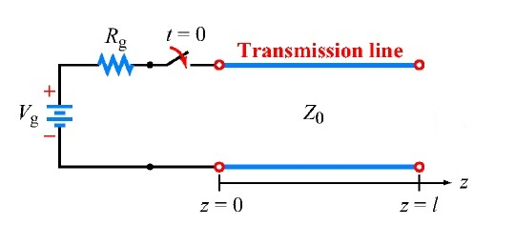The adjacent transmission line circuit has Vg = 12 V, Rg = 50 Ω, Z0 = 50 Ω, and .
7. Complete the bounce diagram below starting at switch closure time t = 0. The time T on the bounce diagram equals l/up, where l is the length of the transmission line and up is the phase velocity along the transmission line. You can either add lines to the empty bounce diagram below using **Insert** → **Shapes** in Word or hand draw the lines, although your homework submission needs to be in electronic format. Include the voltage magnitude of each line displayed on your bounce diagram. (4 points.)

*All other bounces will be multiplied by the reflection coefficient at the generator, which is zero. So, there are no bounces past the second line.*

1. From your bounce diagram, complete the following two voltage versus time graphs, starting at time t = 0. You can either add lines to the empty voltage versus time graphs below using **Insert** → **Shapes** in Word or hand draw the lines, although your homework submission needs to be in electronic format. (4 points.)